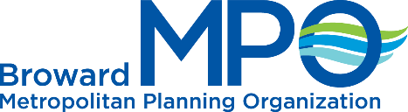
Request
to SPEAk
(Please Print)
Date:
Name:

Address: |  | Zip Code:
Phone: | Email:
ACTION ITEM:

ITEM NUMBER:

NON-ACTION ITEM:

ITEM NUMBER:
GENERAL COMMENTS:

ITEM NUMBER:

Note: Speaker will be called in order of sign-in.
Comments will be limited to three (3) minutes per speaker.
For complaints, questions or concerns about civil rights or nondiscrimination; or for special requests under the Americans with Disabilities Act, please contact Erica Lychak,
Title VI Coordinator at (954) 876-0058 or Lychakerowardmpo.org.
SPEAKER CARD
Broward MPO | 100 West Cypress Creek Road, Suite 650
Fort Lauderdale, FL 33309 | (954) 876-0033 | info@browardmpo.org

